Name: Mrs. Rupali N Hosmani.

Course: Executive Post Graduate Certification in Cloud Computing

Contact No. 7720003531

**Assignment 2: Docker**

**Task To Be performed:**

**A] Docker-Assignment 1:**

● Pull ubuntu container

● Run this container, and map port 80 on the local

● Install apache2 on this container

● Check if you are able to access the apache page on your browser

Steps:

1.Create an ubuntu EC2 instance ,connect ,& install docker.io on the ubuntu machine.

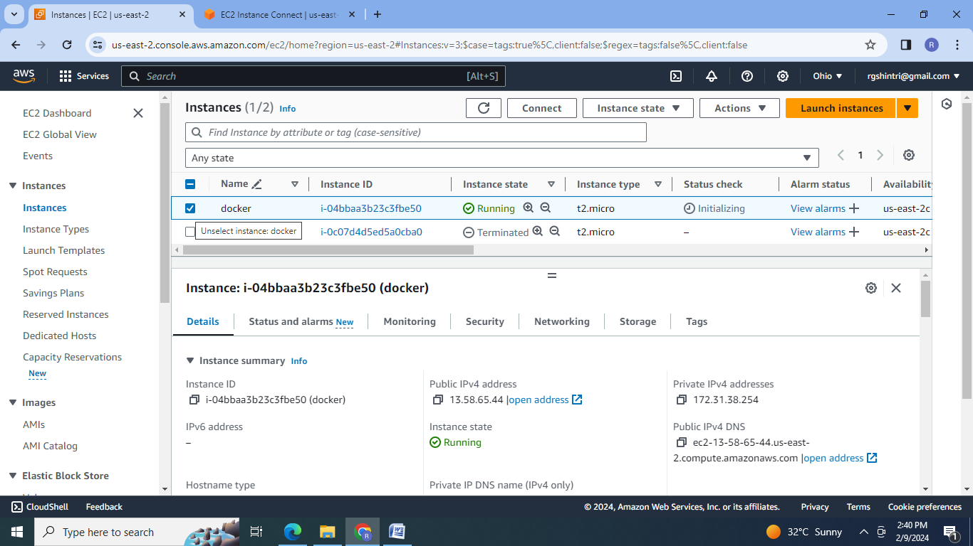

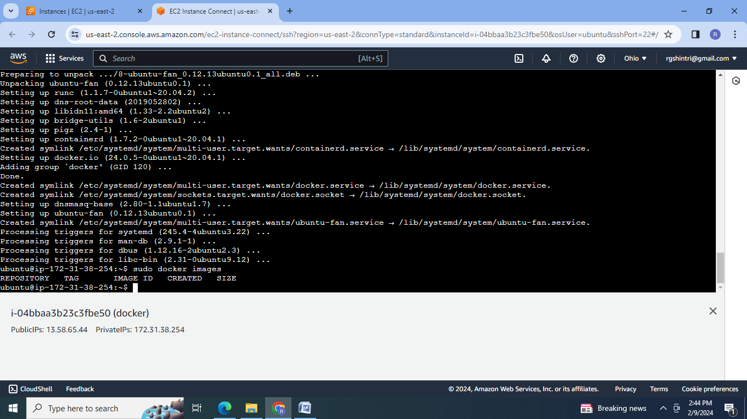

2.Pull ubuntu image

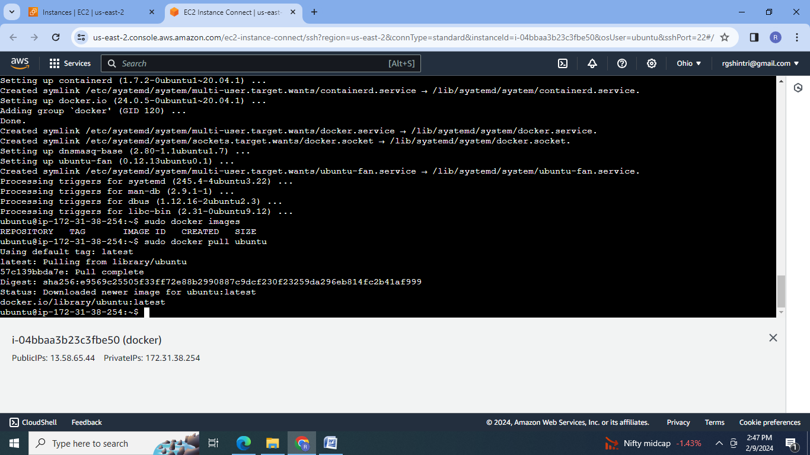

3. Create this container, and map port 80 on the local :

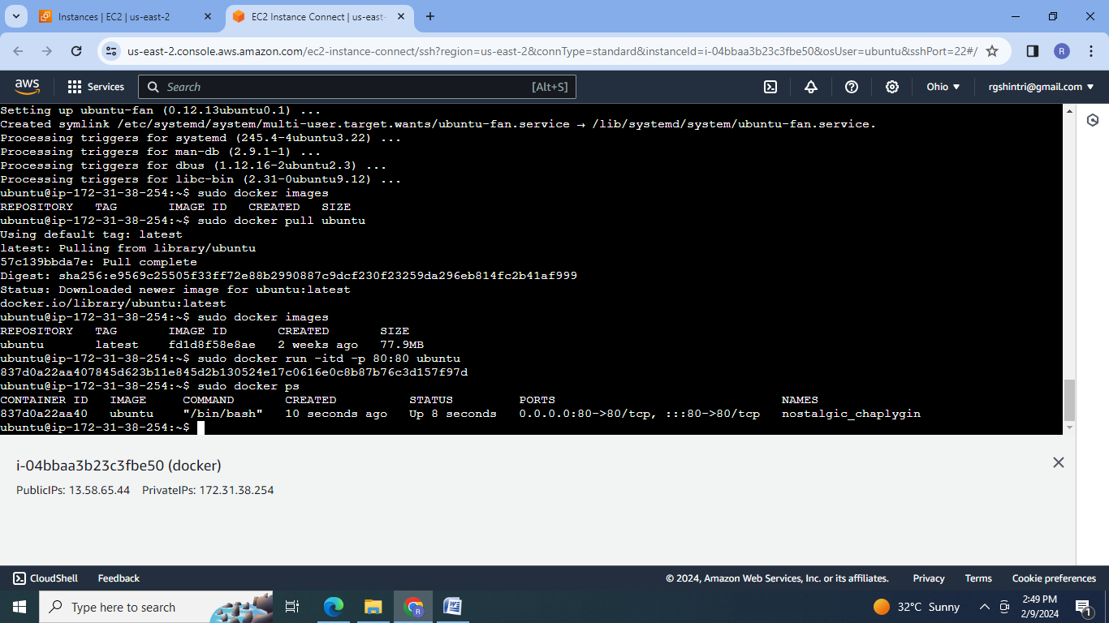

4. Install apache2 on this container:

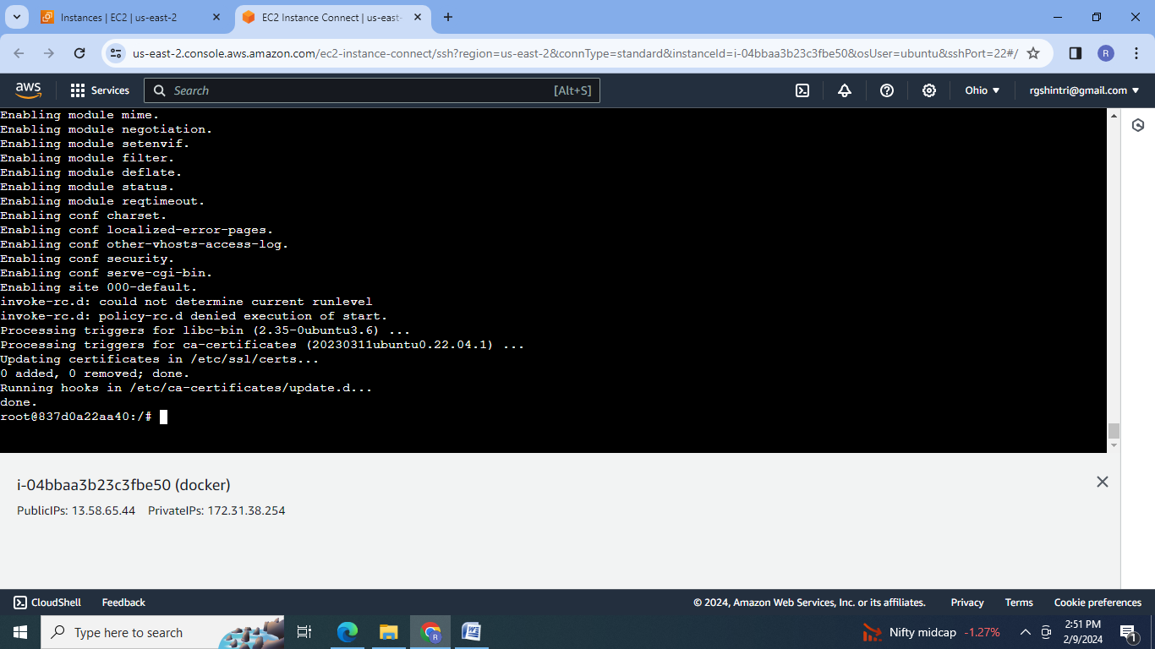

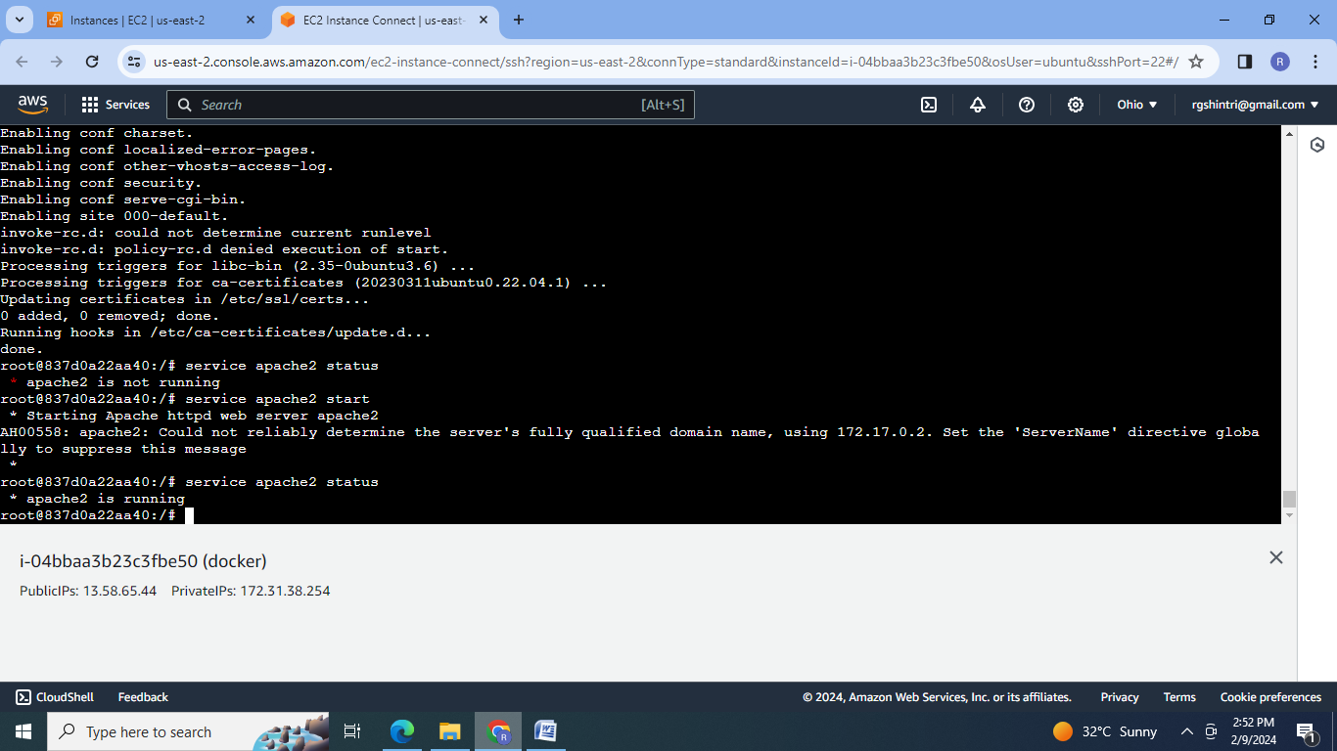

5. Check on browser to access the apache page :

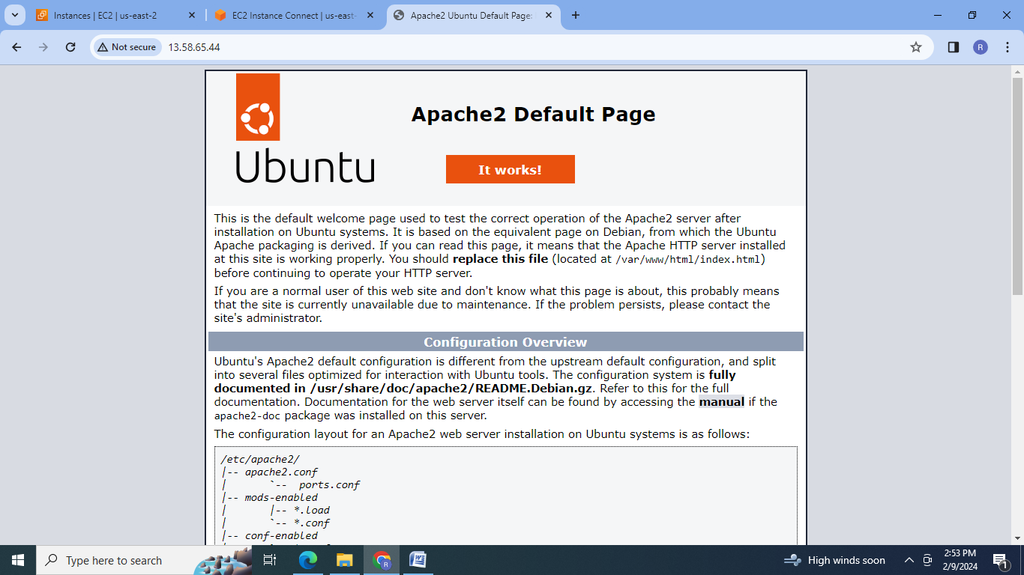

**B] Docker-Assignment 2:**

● Save the image created in Assignment 1 as a Docker image

● Launch container from this new image and map the port to 81

● Go inside the container and start the apache2 service

● Check if you are able to access it on the browser

Steps:

1. Save the image created in Assignment 1 as a Docker image

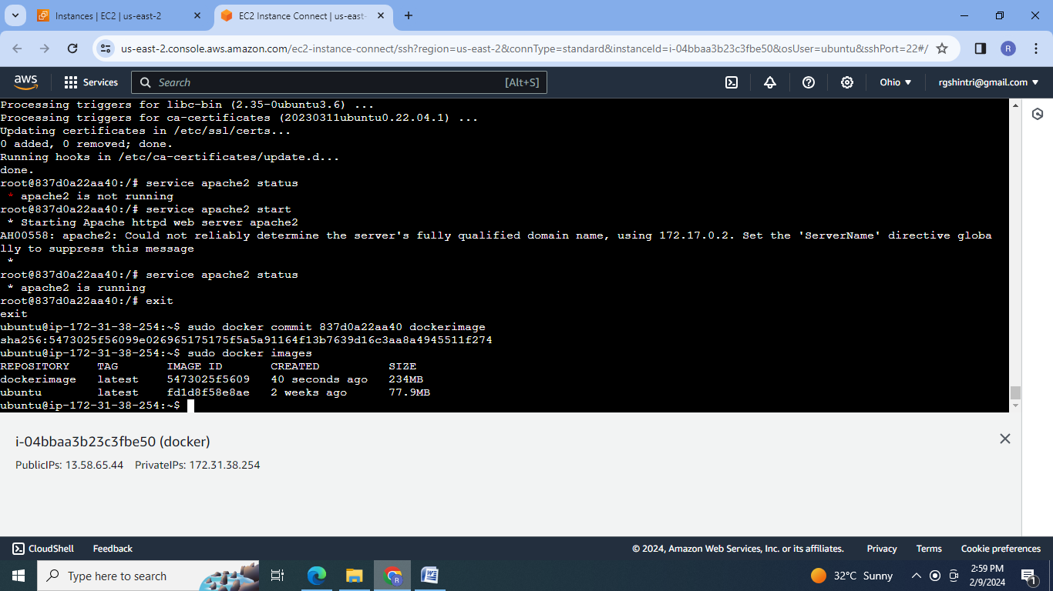

2. Launch container from this new image and map the port to 81

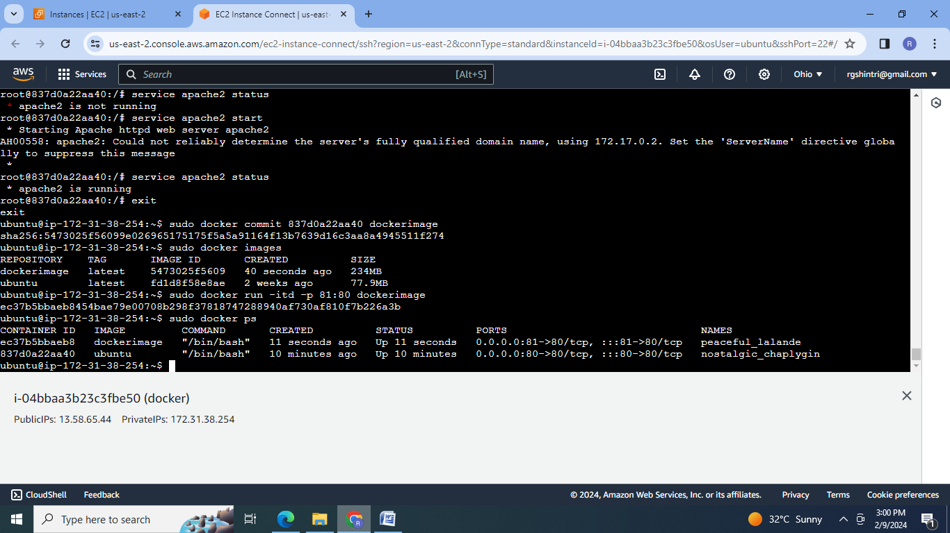

3. Go inside the container and start the apache2 service :

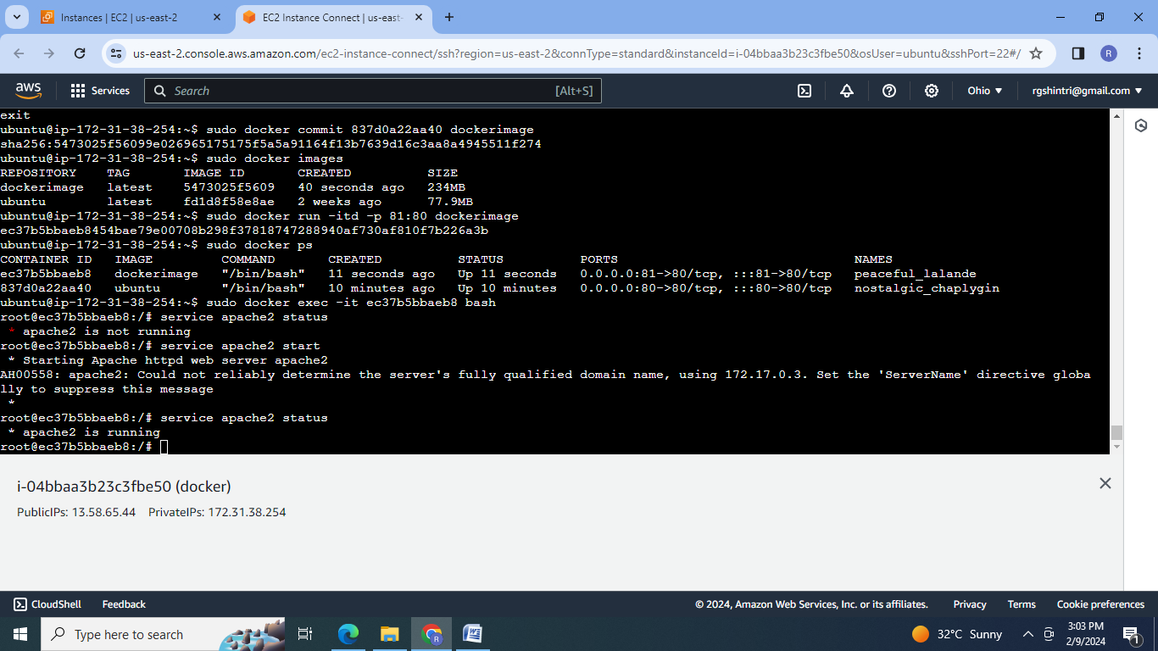

4. Check to access apache2 web page on the browser:

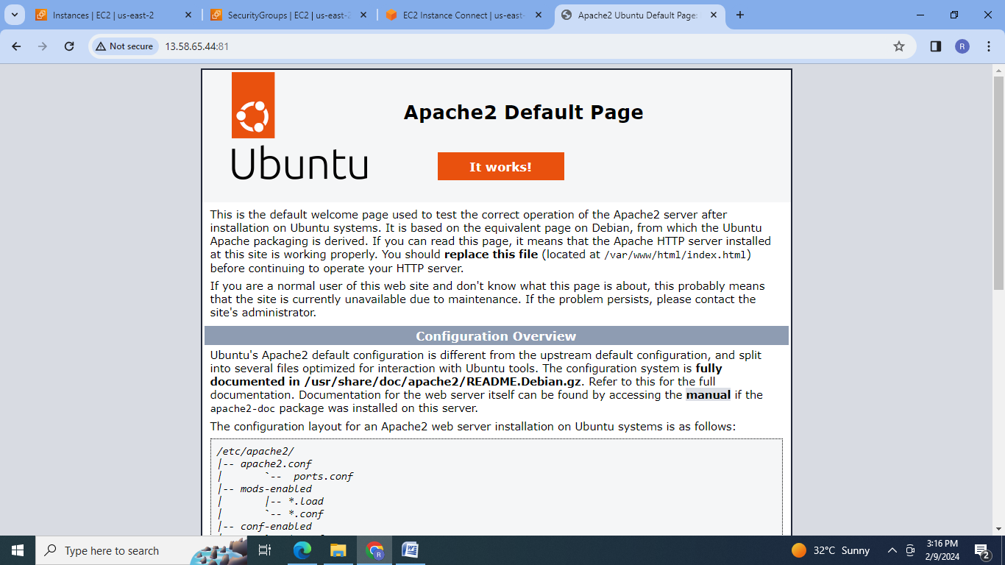

**C] Docker-Assignment 3:**

● Use the saved image in the previous assignment

● Upload this image on Dockerhub

● On a separate machine pull this dockerhub image, and launch it on port 80

● Start the apache2 service

● Verify if you are able to see the apache2 service.

Steps:

1.Ssaved image in the previous assignment

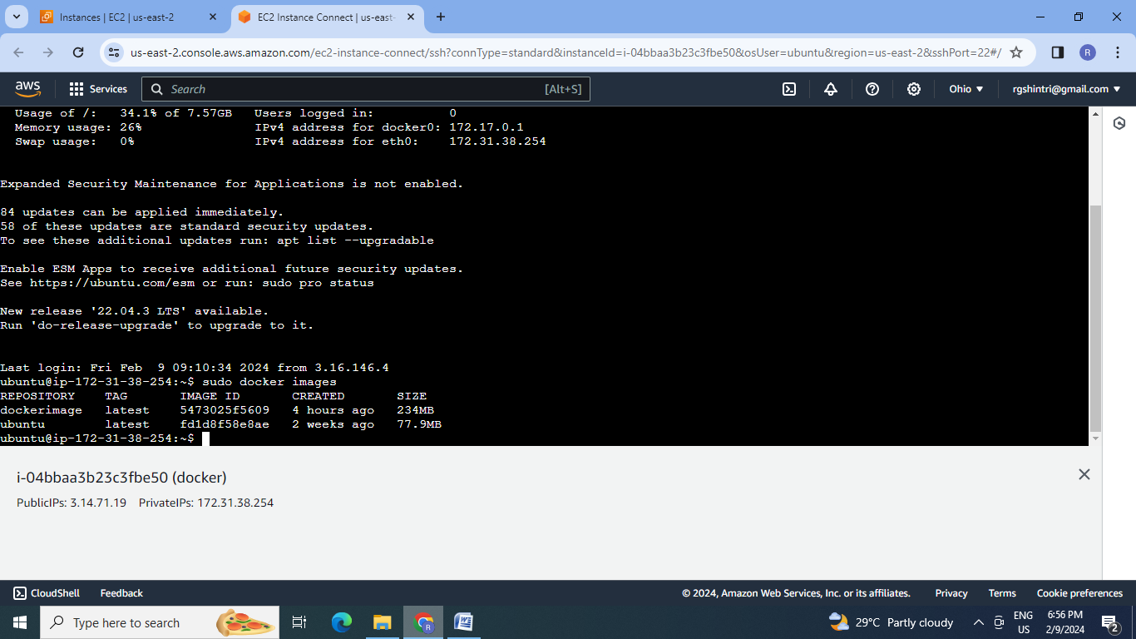

2. To upload this image on Dockerhub, login ,tag & then push to dockerhub.

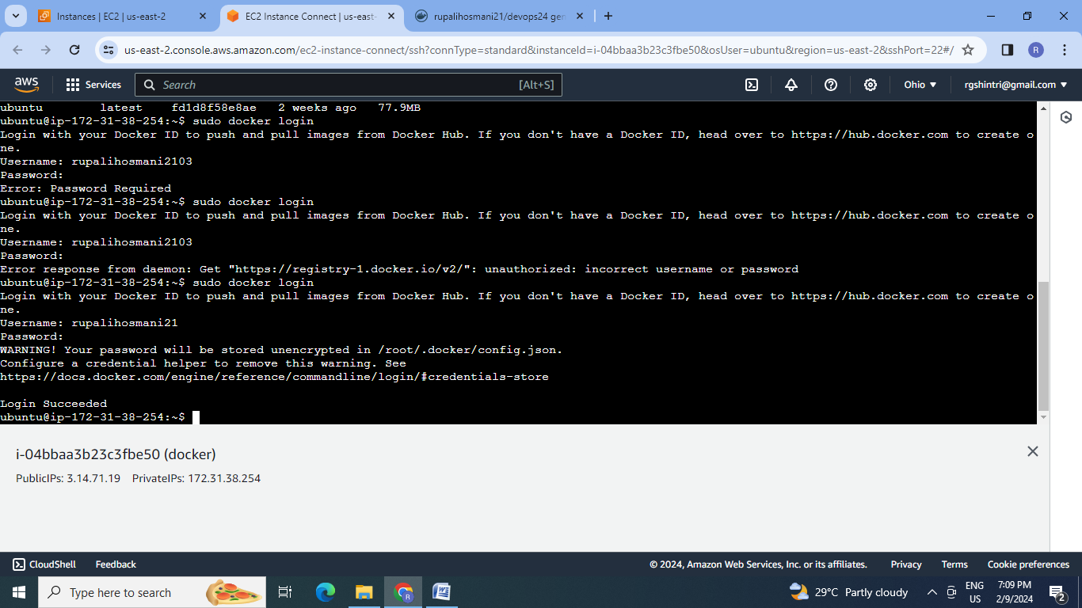

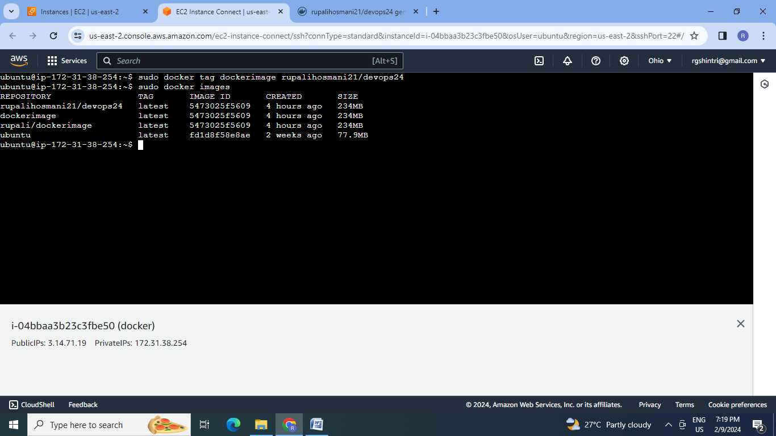

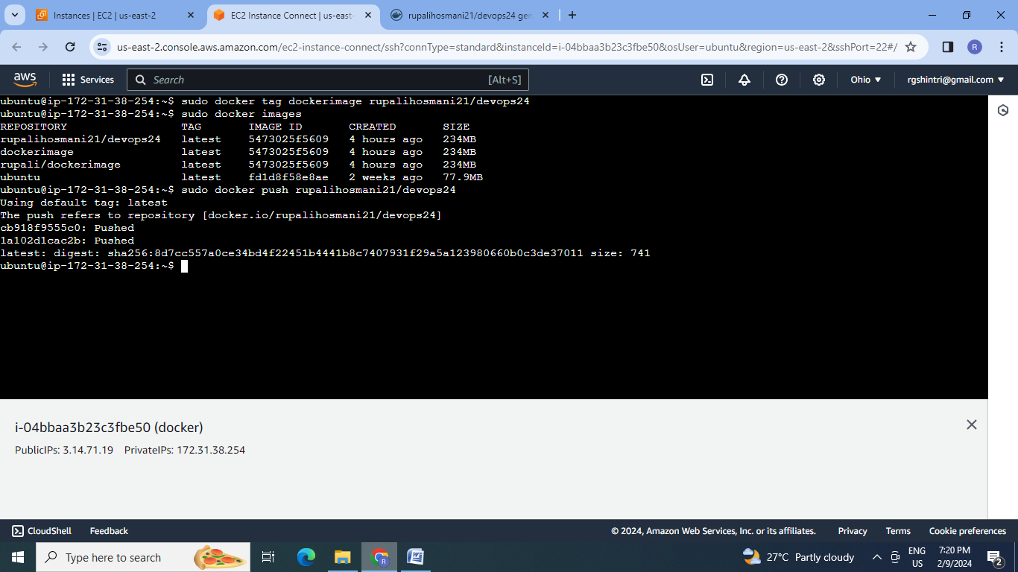

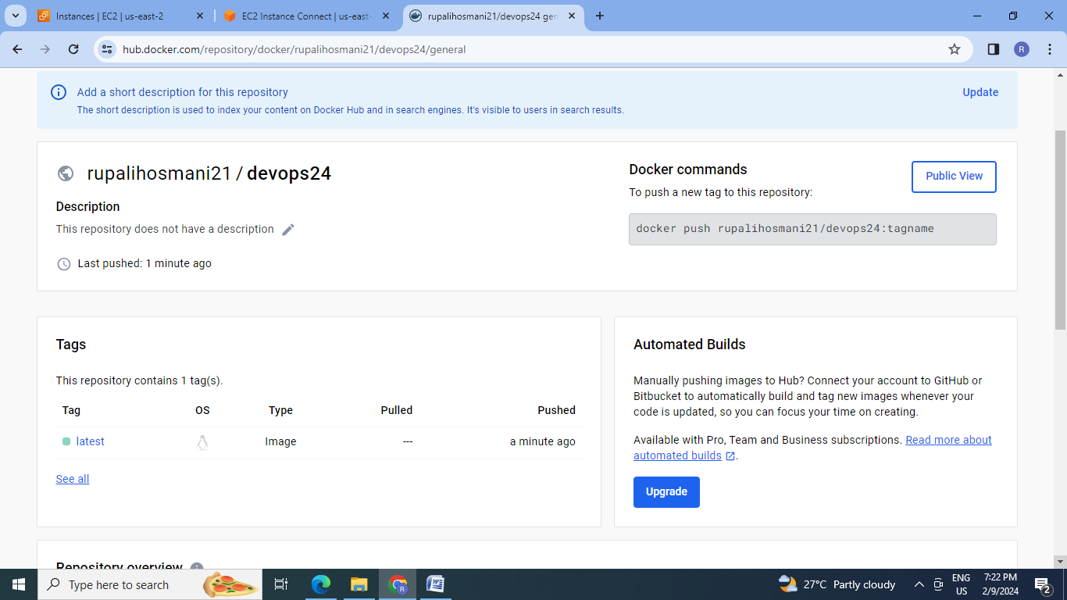

3.Create a separate machine

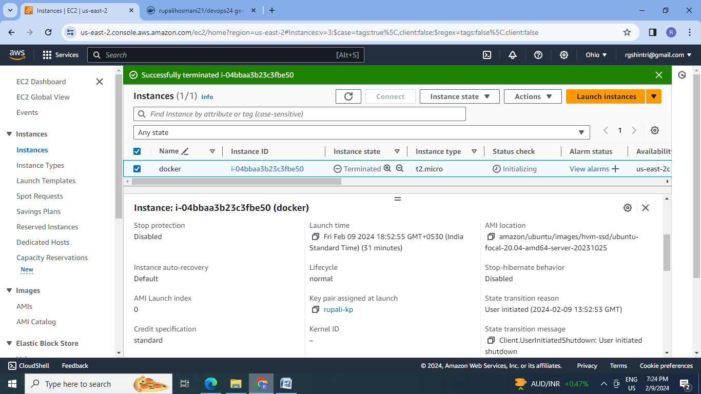

New instance:

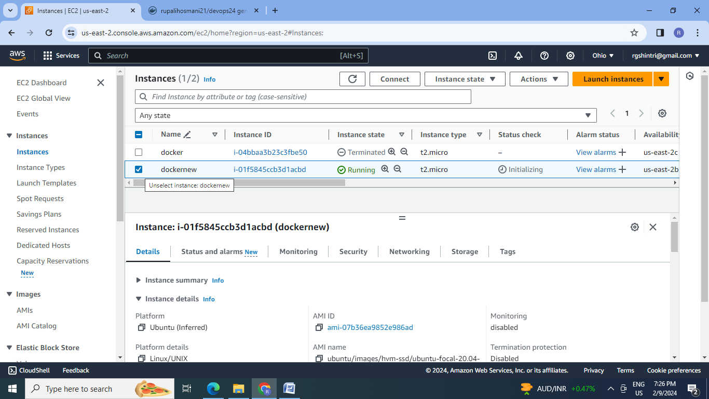

4. Pull this dockerhub image by connecting the machine , updating and installing the docker.

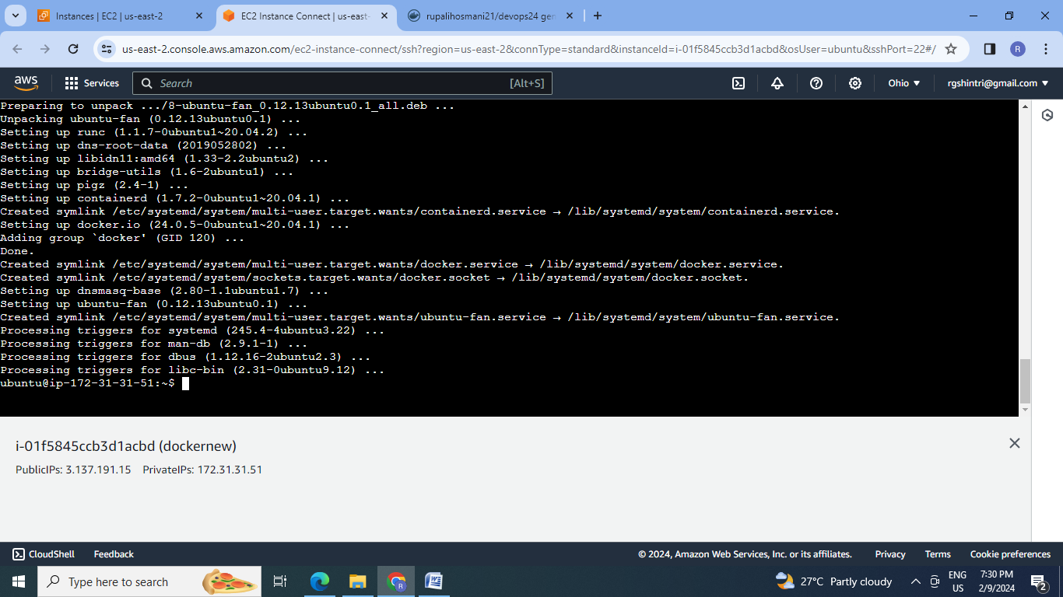

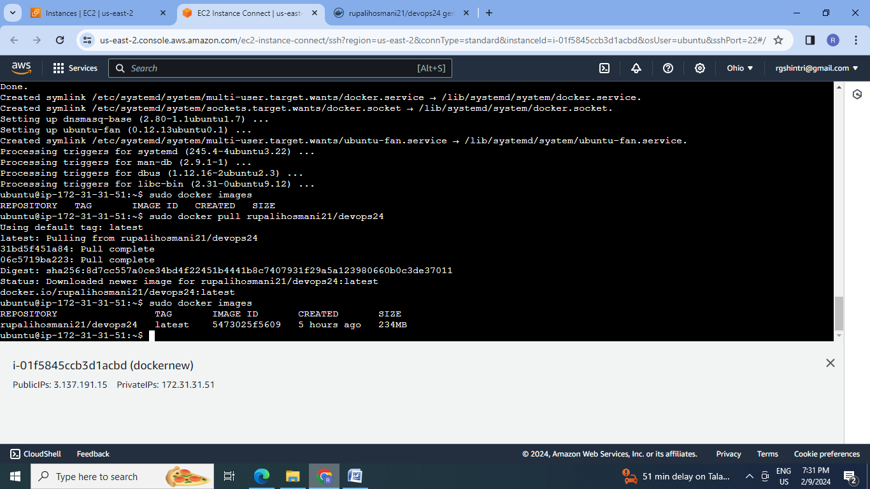

5.Create the container and launch it on port 80:

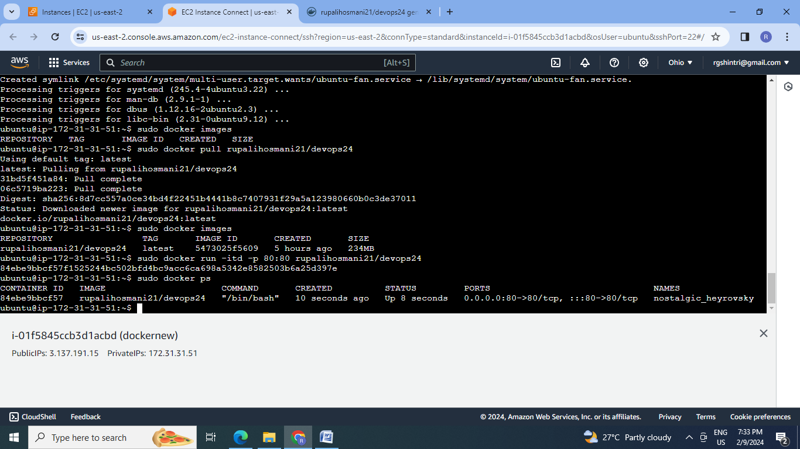

6. Start the apache2 service inside the container:

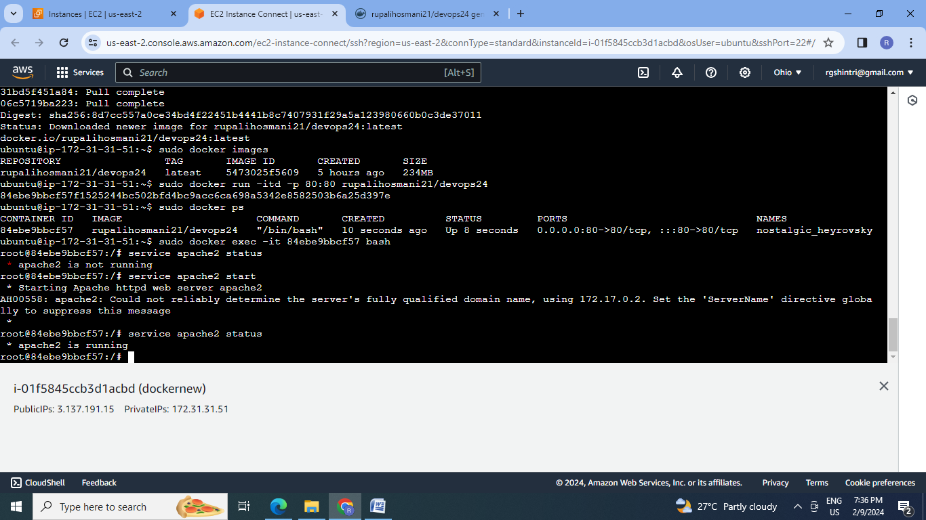

7. Check the apache2 service on browser

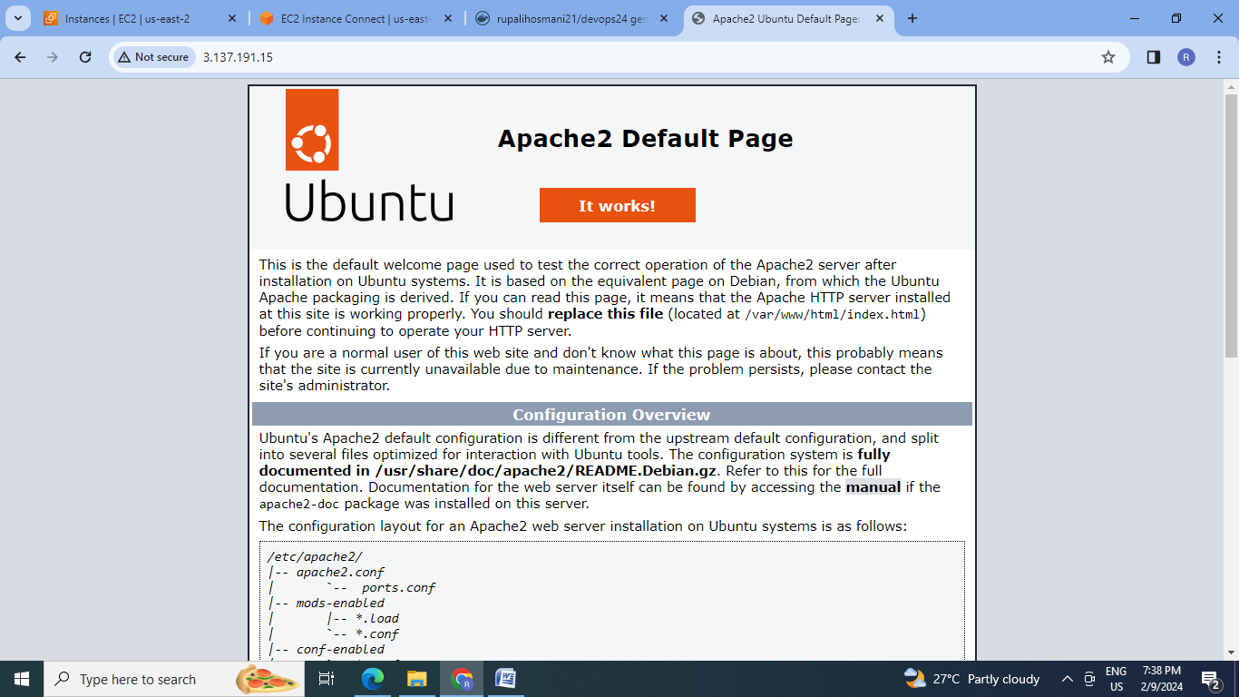

**D] Docker-Assignment 4:**

Create a dockerfile with the following specs

● Ubuntu container

● Apache2 installed

● Apache2 should automatically run once the container starts.

Submit the dockerfile, for assignment completion

Steps:

1.Create the directory, change to directory and create the Dockerfile.

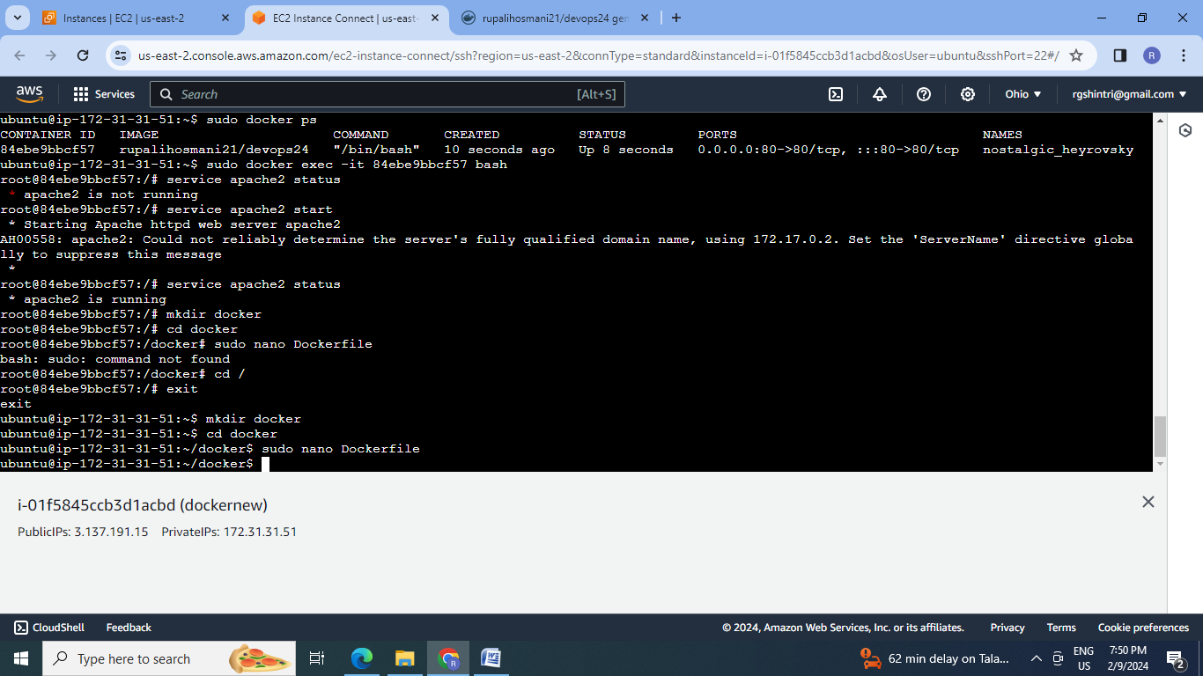

2.Dockerfile: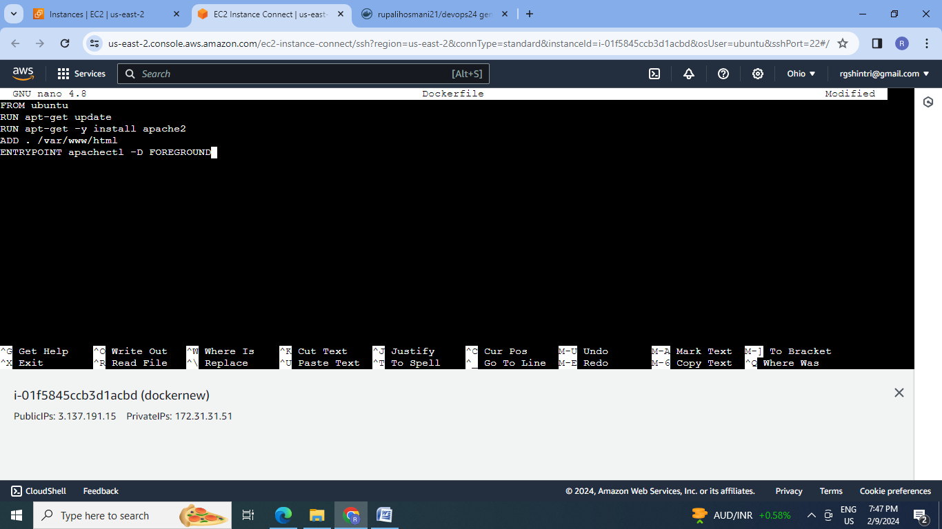

3.Create the image by using docker build

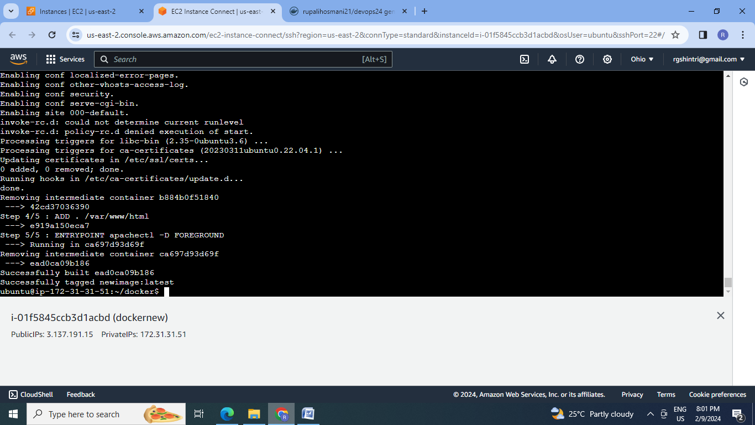

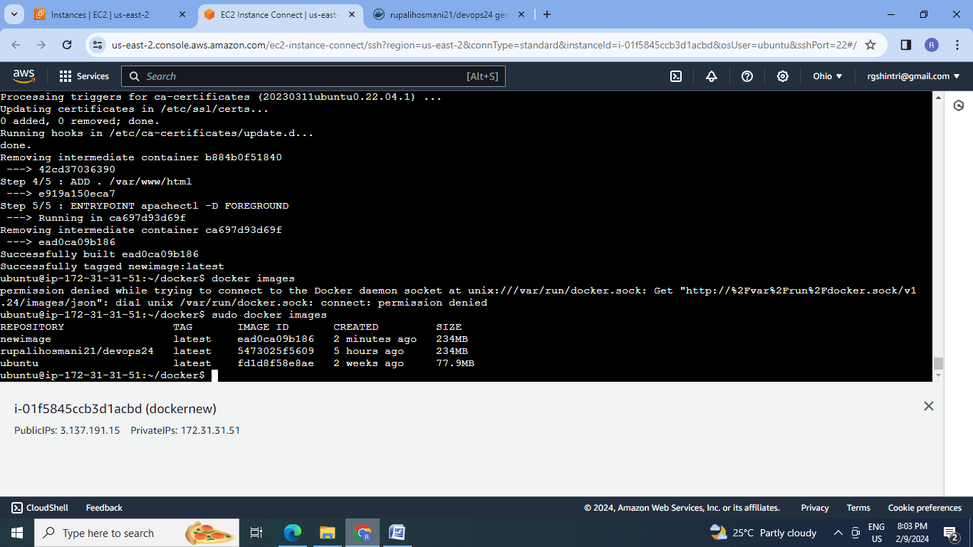

4. Run the container

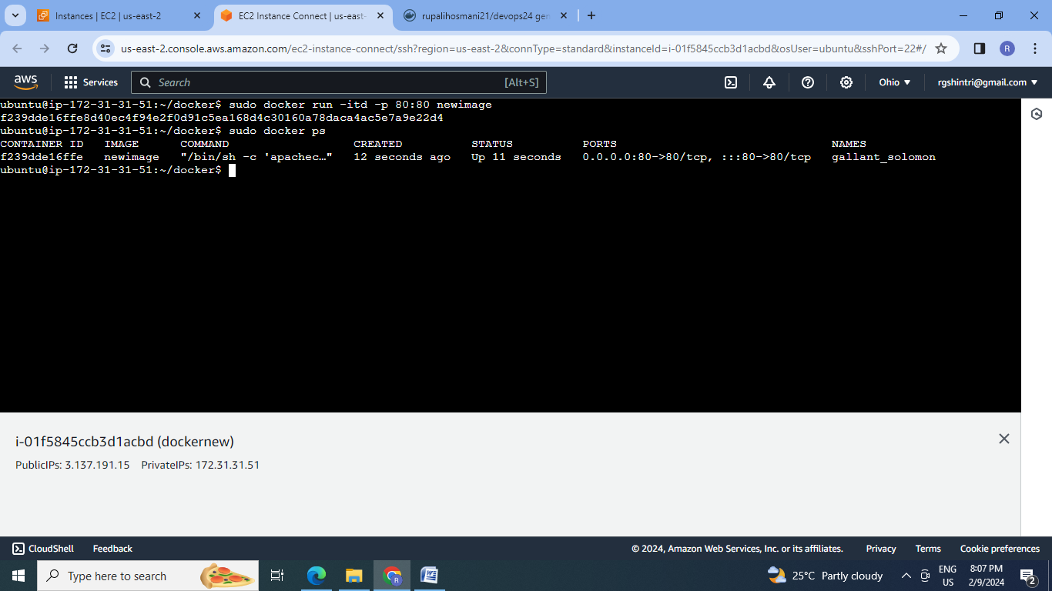

5. Launch the container & check the apache web page on browser

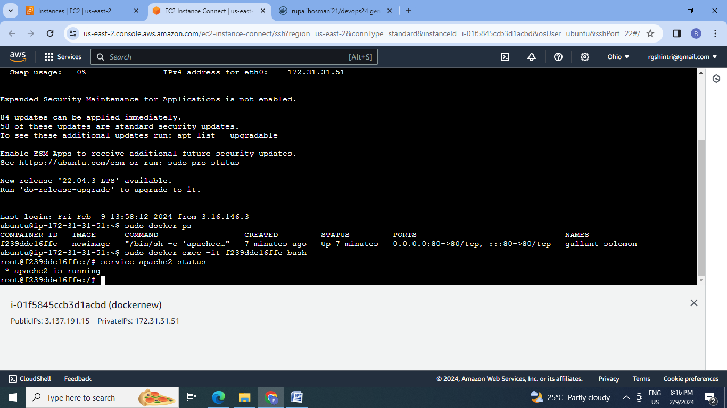

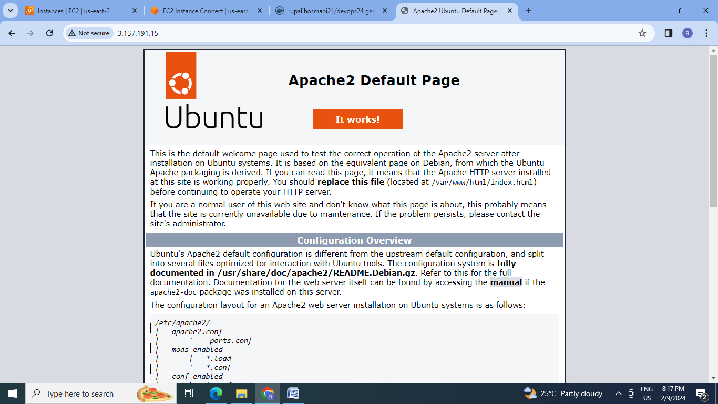

**E] Docker-Assignment 5:**

● Create a sample HTML file

● Use the Dockerfile from the previous task

● Replace this sample HTML file inside the docker container with the default page

Steps:

1.Create HTML file:

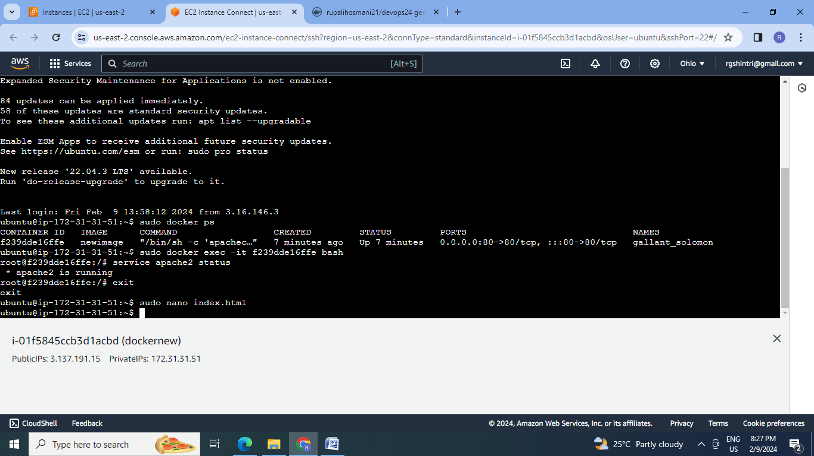

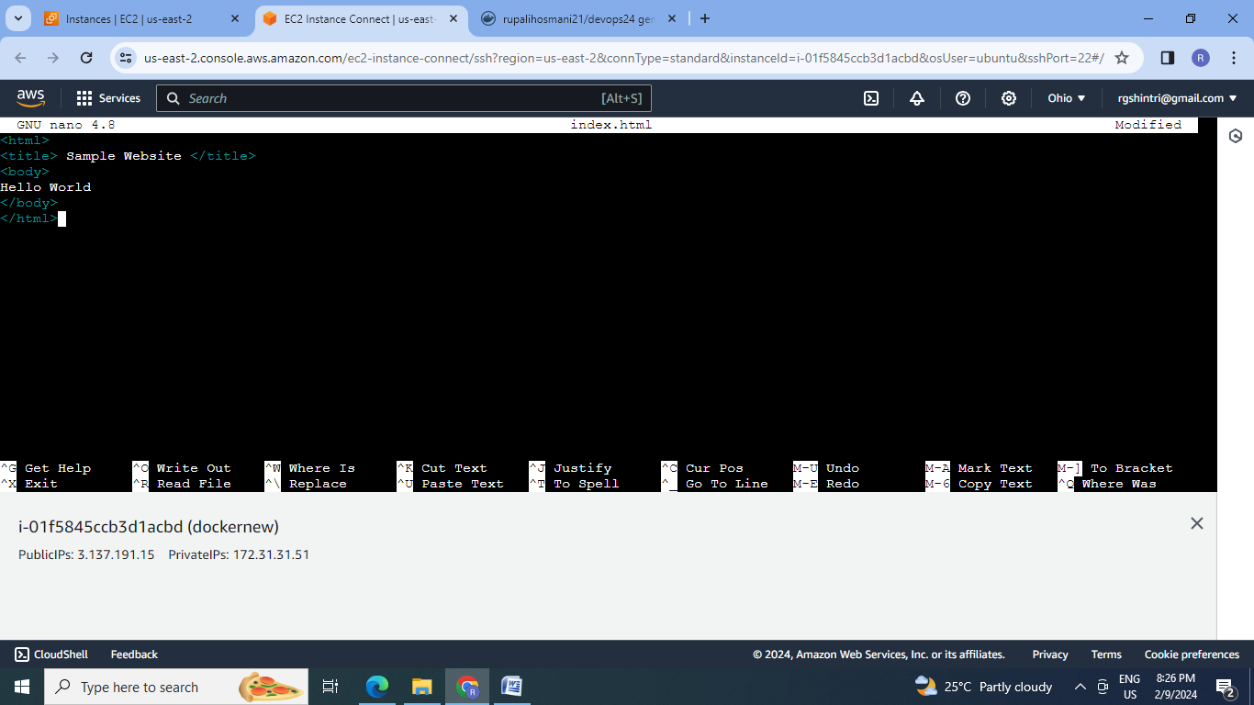

2. Use the Dockerfile from the previous task & replace this sample HTML file inside the docker container with the default page

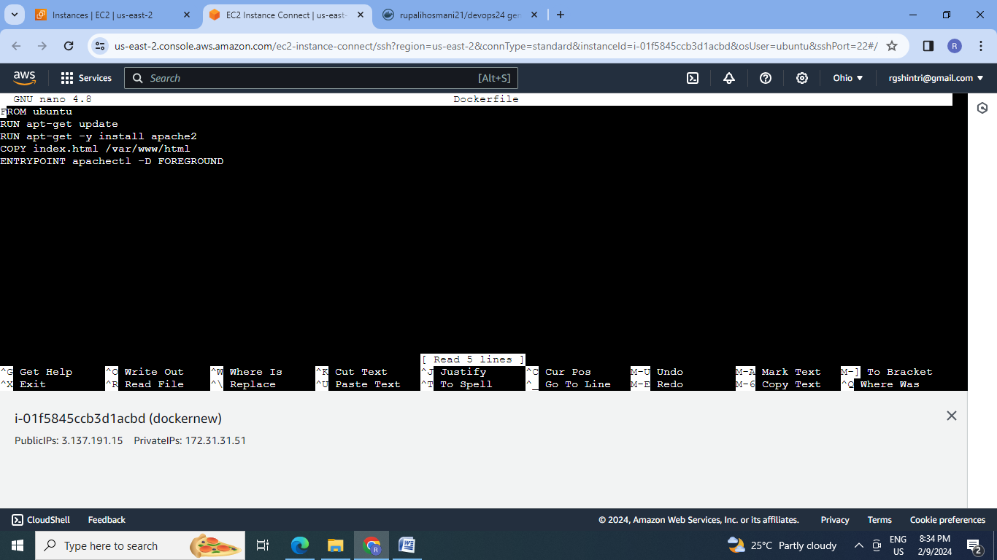

3.Create the image

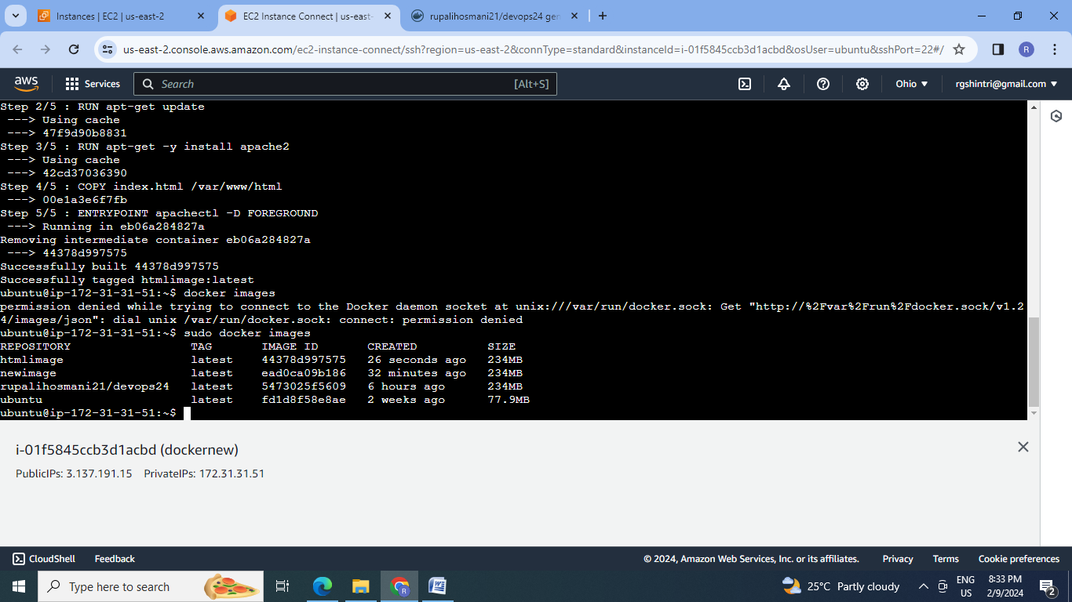

4.Run the container:

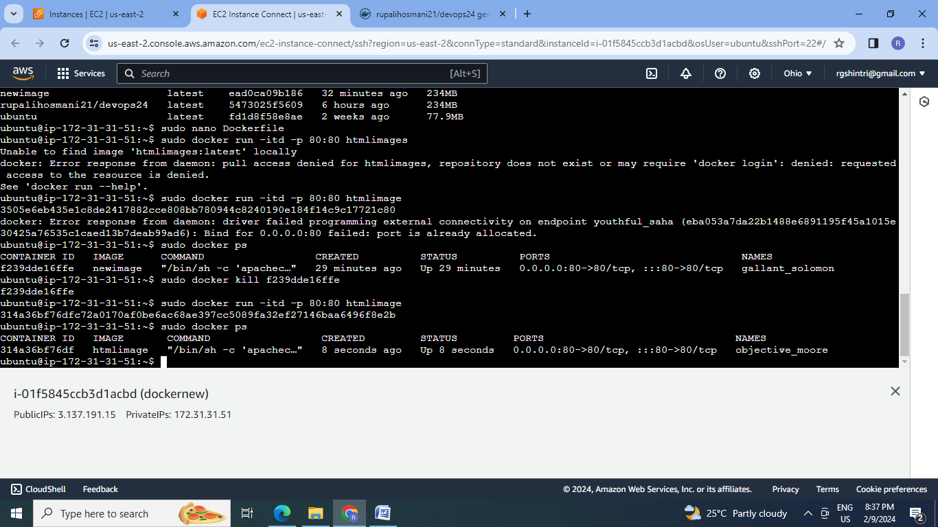

5.Check the html page on browser

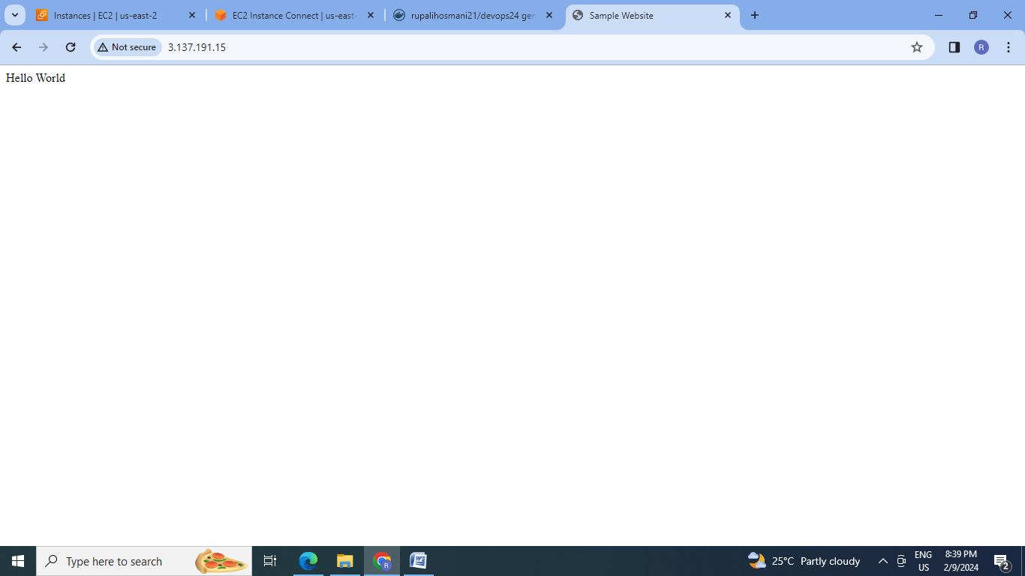

**Conclusion:** Docker is the containerization tool used to build the images and run the containers from them by using the docker components such as docker client , docker daemon and docker hub.

